**Implementation of Big Data and IoT/AI Technologies in Irbid Specialist Hospital for the maternity ward to enable real-time monitoring, data archiving, and automation.**

Rashed Qahah

***Summary:***

In this research project, we explore how these cutting-edge technologies – big data, Internet of Things (IoT), and artificial intelligence (AI) – are being implemented and applied within the maternity ward at Irbid Specialist Hospital. The goal is to revolutionize healthcare practices, with a focus on real-time monitoring, simplified data archiving, and integration of automation features. The research focuses on details related to the challenges faced by smart hospitals, and how to solve these problems. The research thus envisions an advanced healthcare environment that prioritizes efficiency, accuracy, and patient well-being.

1. Introduction

The Internet of Things (IoT) stands at the forefront of modern technological development for the future, shaping a connected world where devices, machines and systems communicate seamlessly and efficiently. Which comprehensively explores the Internet of Things, delving into its definition, applications, advantages, and complex challenges it faces. As a revolutionary concept, IoT is an intelligent, interoperable network that weaves nodes into a dynamic global infrastructure. It embodies the idea of communication without restrictions, facilitating the exchange of information between anything, anywhere, and at any time. In recent years, the Internet of Things has received significant attention, and its applications extend across diverse fields, showcasing its transformative potential. (H. Ali, M. Badawi and Arafat Ali, 2015)

The current era is witnessing the rise of smart technologies, and the Internet of Things is a prominent manifestation of this development, often referred to as “Ubiquitous Computing” or “Web 0.3”. As a technology, IoT has gained traction and become a central force in reshaping how we interact with the digital world. Initially conceptualized in 1999 by Kevin Ashton and later named the “Internet of Things” in 2005, the Internet of Things envisions a world where networked devices seamlessly share information about physical objects across the web. Therefore, through the historical development of the Internet of Things, its various definitions, and its applications in real-world scenarios. With an emphasis on self-configuration, interoperable communications, and dynamic global network infrastructure, the Internet of Things promises a future and evolution in which autonomy and privacy coexist harmoniously with intelligent connectivity. This exploration paves the way for a nuanced understanding of the multifaceted landscape of the Internet of Things. (H. Ali, M. Badawi and Arafat Ali, 2015)

In Big Data Science The world of modern science and business revolves around the ubiquity of big data and its analytical prowess. This expansive data set includes information from a variety of sources, including online transactions, emails, multimedia, health records, and countless interactions in the digital landscape. As these datasets grow exponentially, they pose challenges in terms of capture, storage, management, and analysis, exceeding the capabilities of traditional database tools. (SAGIROGLU and SINANC, 2013)

The volume of data creation is staggering, with 5 exabytes generated as of 2003, a volume now produced in just two days. The digital world's data reached 2.72 zettabytes in 2012, is expected to double every two years, and is expected to reach 8 zettabytes by 2015. The era of big data is revealing the opportunities and complexities associated with managing information on an unprecedented scale, shaping the landscape of the digital world. Technology and decision making. (SAGIROGLU and SINANC, 2013)

Big data represents a revolutionary leap from traditional data analysis, and is characterized by three specific components: variety, speed, and volume. The first type of data emphasizes the breadth of big data, which includes structured, semi-structured, and unstructured types. While structured data is easily organized and sorted, unstructured data poses challenges due to its randomness. Semi-structured data includes tags to separate data elements. The second volume, “V,” emphasizes the sheer volume of data, going beyond terabytes and petabytes. The large volume exceeds traditional storage and analysis methods. The third speed, “V,” is pivotal to real-time operations, driving the use of big data as it flows to organizations to maximize its value. Amidst the density of this information lies the crucial aspect of verifying data flow and ensuring data security. Moreover, generating and processing big data should contribute significant value to organizations. The challenges and opportunities of big data are clear, driving the need for sophisticated analytics to extract useful insights for informed decision-making. (SAGIROGLU and SINANC, 2013)

Artificial Intelligence (AI) represents a dynamic and interdisciplinary field at the crossroads of science and engineering, with a primary focus on creating systems that emulate intelligent behaviors found in human cognition. Encompassing facets like perception, natural language processing, problem-solving, learning, and environmental interaction, AI seeks to unravel the principles underpinning intelligent behavior in humans, animals, and artificial entities. This scientific pursuit aligns with engineering goals such as developing intelligent agents, formalizing knowledge, streamlining human-computer interaction, and crafting human-machine systems that capitalize on the synergies between human and automated reasoning. Beyond a mere application of AI, the field has evolved into a multifaceted discipline with broad applications across various domains, including computing, mathematics, linguistics, psychology, neuroscience, engineering, statistics, economics, and philosophy. (Tecuci, 2012)

The advantages of AI extend beyond standalone applications, with its influence permeating complex systems, making them intelligent and adaptable. In an increasingly interconnected world, AI contributes to diverse applications, enhancing capabilities in reasoning, natural language processing, and learning. While specific systems like expert or planning systems exemplify direct applications of AI, the broader landscape witnesses AI systems integrated as intelligent components within complex applications. These components imbue applications with intelligence, enabling them to process natural language, reason with knowledge, or learn and adapt to evolving scenarios. The architecture of an intelligent agent, a cornerstone in AI, captures its essence—a knowledge-based system that perceives its environment, reasons to interpret perceptions, and acts upon the environment to achieve predefined goals. (Tecuci, 2012)

The continuous improvement through learning accentuates the autonomy and dynamism of AI systems, propelling their effectiveness in diverse problem-solving domains. The multifaceted nature of AI positions it as a key technological driver, continually evolving and contributing to novel applications that define the contemporary landscape. (Tecuci, 2012)

My research seeks to achieve transformative progress by presenting and how to implement cutting-edge Big Data, Artificial Intelligence and Internet of Things (IoT) technologies within the maternity ward at Irbid Specialist Hospital in Jordan. The primary goal is to revolutionize healthcare practices, with a special focus on real-time monitoring, simplified data archiving, and integration of automation features. By seamlessly integrating big data and Internet of Things technologies into the existing infrastructure, the research aspires to increase maternity care services in the hospital, and raise their efficiency, accuracy and overall quality.

My research examines and explains how Big Data, IoT and AI technologies can be applied with a range of benefits to the maternity ward at Irbid Specialist Hospital. The integration of these technologies is expected to enhance real-time monitoring capabilities, allowing, for example, healthcare professionals to access important information instantly using these technologies. In addition, the project seeks to revolutionize data archiving practices, ensuring a comprehensive and accessible repository of patient historical information. The introduction of automation features is expected to streamline processes, mitigate manual errors and improve resource allocation. Ultimately, the overarching goal is to raise the standard of maternity care services provided by the hospital, fostering a technologically advanced healthcare environment that prioritizes efficiency, accuracy and patient well-being.

It addresses the transformative impact of Internet of Things (IoT) technology on smart hospitals, presenting a comprehensive solution implemented at the People's Hospital in Jiangsu Province, China. The study presents a cloud platform for smart services consisting of four integrated components: smart data collection stations, a data collection network, a smart data analysis platform, and a service integration platform. The practical application of this scheme in hospitals has achieved noteworthy advantages, focusing on reducing the workload of medical care, relieving pressure on medical staff, enhancing patient satisfaction, and overall improving the social impact of the hospital. The People's Hospital of Jiangsu Province has developed a software-defined IoT intelligent hospital to streamline service operations, improve doctor-patient relationships, and enhance medical security. The hospital integrates IoT, artificial intelligence and cloud computing technologies to collect, process and display data. The architecture includes smart terminals, a data collection network, a data processing platform, and a service integration platform for seamless communication. The smart hospital will provide unified management platforms, comprehensive data centers, cloud services and visualizations for optimal healthcare delivery. (Jing et al., 2020)

The study acknowledges the support of the natural sciences research program in universities in Jiangsu Province and provides a comprehensive overview of the research landscape in IoT-based smart hospitals. In addressing the challenges of traditional smart hospitals, such as inefficient network resource use due to gateways, the study introduces a software-defined IoT smart hospital, integrating IoT, artificial intelligence (AI), and cloud computing. (Jing et al., 2020)

Some hospitals have good quality infrastructure used primarily for the Hospital Information System (HIS). However, challenges arise in terms of the lack of a clear technology-driven strategy and difficulties in starting big data projects despite having an adequate budget. The decentralized nature of IT systems within different departments leads to duplication of data and systems. (Noonpakdee, Phothichai and Khunkornsiri, 2019)

Smart hospitals face numerous challenges in their transformation, including patient monitoring, data accuracy, security and privacy concerns, cost-effectiveness, and intelligent data processing. The demand for 24/7 health monitoring and quick decision-making necessitates the use of IoT and other technological solutions. Data accuracy is crucial, as incorrect information can lead to faulty processing. Security and privacy concerns are also significant, with potential data misuse and manipulation resulting in financial implications. The cost-effectiveness of smart hospitals is also a concern. However, the smart hospital market presents significant opportunities, with technologies like blockchain, telebiometry, and precision medicine promising. Future hospitals will provide acute care and disease prevention services, with smart solutions like surgical robots and advanced navigation platforms enhancing patient care. Continuous learning and autonomous behavior are crucial for their sustainable success. (MP, 2019)

1. Related work

The study addresses the increasing digitization of healthcare systems, resulting in a vast amount of medical data. While private hospitals in Thailand have reaped benefits from big data analytics, the research highlights the difficulties faced by public hospitals in adopting this technology. The case study is centered on a tertiary healthcare facility under the Ministry of Public Health in Thailand. The challenges of implementing big data are categorized into technology, data, human, and organizational aspects. (Noonpakdee, Phothichai and Khunkornsiri, 2019)

Bumrungrad International Hospital aspires to establish itself as a premier global healthcare institution through the application of cutting-edge medical technology, emphasizing proactive treatment with a patient-centric approach and operational excellence focused on patient safety. The hospital has developed artificial intelligence (AI) and health-related technologies for the analysis, diagnosis, and treatment of medical cases. Utilizing a big data platform, Bumrungrad International Hospital efficiently processes extensive datasets, delivering personalized information and recommendations directly to patients. This platform plays a crucial role in streamlining administrative tasks, facilitating the coordination and management of patient data, and expediting the delivery of information to clinicians, doctors, and patients. (Noonpakdee, Phothichai and Khunkornsiri, 2019)

Shankar Krishnan's research at Wentworth Institute of Technology also explores the use of analytics in the healthcare sector, focusing on the application of big data to improve patient care and reduce costs. The study highlights the challenges and opportunities associated with the volume, speed, diversity and veracity of complex healthcare data, with the goal of enhancing patient care while containing costs. (M. Krishnan, 2016)

One notable application highlighted in the research includes implementing big data analytics at Seattle Children's Hospital in Washington using IBM technology. The hospital uses big data analytics to improve diagnosis and patient care for a large number of patients. The system takes advantage of data from various sources within the hospital, and reveals commonalities between patients to enhance the accuracy and speed of diagnosis. Additionally, the study discusses the application of big data analytics in the field of treatment, citing examples such as Intel and Oregon Health and Science's Collaborative Cancer Cloud Platform, which enables precise cancer treatment by sharing basic patient information between hospitals. The research underscores the potential benefits of using healthcare analytics, including rapid and accurate diagnosis, personalized treatment, cost savings, and overall improvement in healthcare quality. However, the study acknowledges that there are challenges such as privacy, security, ease of use and standardization that need to be addressed for successful implementation. Unfortunately, the specific hospital in which the research was conducted was not explicitly stated in the information provided. (M. Krishnan, 2016)

This research published in the journal Sensors (2023) presents a pioneering approach to maternity healthcare monitoring through the development of Iod-Nets, an intelligent IoT-based healthcare monitoring system designed for pregnant mothers and mobile fetuses. The study conducted by Rajkumar Etienne of the Department of Computer Science and Engineering and V. Geetha from the Department of Information Technology at Puducherry Technological University in India is integrating Internet of Things (IoT) sensors and artificial intelligence (AI) to create an intelligent system for automated diagnosis in high-risk pregnancies. IoT sensors collect important clinical data for the mother, including temperature, blood pressure, oxygen saturation level, heart rate, and fetal heart rate, which is then stored in the cloud for monitoring and forecasting purposes. (Ettiyan and Geetha, 2023)

The research was conducted based on data collected from nearly 9,000 cases, using various machine learning algorithms such as K-Nearest Neighborhood, Random Forest, Support Vector Machines, Convolutional Neural Networks, and Extreme Learning Machines. The evaluation showed that the proposed 1DOCNN classifier outperformed other algorithms in terms of accuracy, precision, recall, and F1 score, which demonstrated its practicality and efficiency in maternal and fetal monitoring using IoT and artificial intelligence. The study emphasizes the importance of continuous monitoring and early detection of health problems during pregnancy and presents iodine nets as a promising solution for improving maternal and fetal health. (Ettiyan and Geetha, 2023)

The research was conducted at Sri Venkateshwara Hospital in Puducherry, Government of India, using a comprehensive dataset of 101 patients in labor, including antenatal and intrapartum cases. The proposed system presents a comprehensive framework, incorporating IoT sensors, cloud learning algorithms, and an optimal deep learning classifier, showcasing its potential to enhance the field of maternity care and address current challenges in cost, operational complexity, and misclassification rates. (Ettiyan and Geetha, 2023)

1. Discussion and Analysis

**Qualitative research** is a methodological method that seeks to explore, research, and understand the subjective aspects of human and social experiences, feelings, and thoughts through the collection and analysis of non-digital data. The primary goal of qualitative research is to extract ideas and concepts that may lead to the formulation of testable hypotheses. This method departs from quantitative research, which focuses on numerical data, and relies instead on non-numeric data, usually in narrative form. This approach is often used to gain insight into people's experiences, perceptions, beliefs and behaviors in their natural context. The authors emphasize the importance of qualitative research in fields such as anthropology, sociology, education, health sciences, and history, highlighting its role in revealing patterns and new perspectives and providing a deeper understanding of social phenomena. (Chinyere. N. and H. U., 2023)

Ethnography is a qualitative research method that involves immersing the researcher in a community or organization to observe behaviors and interactions. It offers a close-up view of a group's customs and culture, but faces challenges like labor-intensive nature, potential observer bias, and ethical considerations. Grounded theory, an inductive approach, is beneficial for real-world applicability and new discoveries, but also faces challenges like participant recruitment, time-consuming data collection, and analysis difficulties. This paper provides a comprehensive guide to qualitative research methods. (Chinyere. N. and H. U., 2023)

**Quantitative methods** are used to summarize, find patterns, predict, and test causal connections. It is systematic empirical research that uses numerical data and statistical methods to analyze relationships, patterns, and trends. This research method is concerned with collecting and analyzing data in an organized and objective manner to draw conclusions and make generalizations about a society or phenomenon. Allowing researchers to generalize the results to broader population groups. The authors highlight the importance of quantitative research in providing a numerical understanding of various topics, from studying the spread of a disease in a country to evaluating the effectiveness of interventions. The entry introduces the basic elements of quantitative research, such as observational and experimental research methods, hypothesis testing, and statistical analyses. (Rana, Oldroyd and Luna Gutierrez, 2021)

Quantitative research uses descriptive and inferential statistics to analyze data. Descriptive statistics provide numerical descriptions of data, while inferential statistics estimate relationships between variables and make inferences about larger populations. The entry explains the level of significance, P value, and error types in hypothesis testing. It also provides insight into statistical tests used in inferential statistics, such as chi-square, correlation tests, t-tests, ANOVA, and regression analysis. (Rana, Oldroyd and Luna Gutierrez, 2021)

|  |  |  |
| --- | --- | --- |
| **Aspect** | **Qualitative Research** | **Quantitative Research** |
| **Nature of Data** | Non-numeric, narrative, explores subjective experiences | Numeric, statistical, focuses on objective measurements |
| **Goal** | Explore and understand subjective aspects of human experiences | Summarize, predict, and test causal connections |
| **Data Collection** | In-depth, non-digital data collection, often through immersion | Systematic, empirical research using structured methods |
| **Primary Method** | Ethnography, immersion in a community for observations | Surveys, experiments, structured observations |
| **Applicability** | Anthropology, sociology, education, health sciences | Various fields, studying phenomena at a broader scale |
| **Strengths** | Reveals patterns, new perspectives, deeper understanding | Provides numerical understanding, generalizability |
| **Challenges** | Potential bias, labor-intensive, ethical considerations | Rigid protocols, potential lack of depth in understanding |
| **Data Analysis** | Inductive analysis, developing theories from empirical data | Deductive statistical analysis, numerical summaries |
| **Statistics Used** | Descriptive (non-numeric) | Descriptive (numeric) and Inferential statistics |
| **Examples of Methods** | Ethnography, Grounded Theory | Surveys, experiments, chi-square, correlation, ANOVA |

(Rana, Oldroyd and Luna Gutierrez, 2021)

Discuss the findings in the table and build conclusions, recommendations, observations, statistical analysis (if found).

**Open Questions:**

Open-ended questions are a type of survey inquiry that allows respondents or participants to provide detailed, uninhibited answers in their own words. These questions can be compared to essay questions or short answer questions that are often used in academia. The advantage of open-ended questions is their ability to elicit rich and diverse answers, providing researchers with a deeper understanding of participants' perspectives. They offer flexibility, allowing respondents to express themselves freely, making them particularly suitable for qualitative research where in-depth exploration and nuanced insights are crucial. However, these questions come with some challenges, such as potential bias based on respondent clarity and difficulties in recording and analyzing responses. (R Hyman and J. Sierra, 2016)

**Closed questions:**

In contrast, closed questions are a different type of survey inquiry, and are similar to the multiple-choice questions that typically appear on exams. These questions present respondents with a predetermined set of answer options, requiring them to choose the most appropriate option. Closed questions are useful in situations where participants' communication skills are less important, as they simply need to choose from a range of alternatives. They facilitate rapid response, making participants feel like they are making progress in the survey. The structured nature of closed questions also allows for easy coding, data entry, and analysis. However, these questions have limitations, such as providing limited in-depth answers and potentially missing unexpected insights. Formulating effective closed-ended questions can also be difficult as researchers must anticipate all possible answers. (R Hyman and J. Sierra, 2016)

|  |  |  |
| --- | --- | --- |
| **Criteria** | **Open-ended Questions** | **Closed-ended Questions** |
| Communication Skills | Relies on respondents' communication skills. | Communication skills less critical. |
| Speed of Response | Response may take longer. | Quick response time. |
| Depth of Response | Allows for rich and in-depth responses. | Provides limited in-depth responses. |
| Ease of Coding and Analysis | Requires additional effort in coding and analysis. | Easily coded and analyzed, facilitating data processing. |
| Flexibility | Offers flexibility in exploring various perspectives. | Less flexible, as responses are predefined. |
| Potential for New Insights | Likely to reveal unexpected insights and perspectives. | May miss unexpected insights due to predefined options. |
| Record-keeping Challenges | Recording responses can be challenging and may lead to errors. | Recording is more straightforward and less prone to errors. |
| Cost and Tabulation | More costly due to live interviewers and additional data handling. | Cost-efficient, with simplified data handling and tabulation. |

(R Hyman and J. Sierra, 2016)

Dr. Nader Obaidat was the participant in the initial interview, which aimed to collect additional data for the ongoing research. Dr. Obaidat, a medical specialist affiliated with Irbid Specialist Hospital in Irbid, was asked about topics including big data, the Internet of Things, and artificial intelligence. The set of questions posed to Dr. Obaidat consisted of 8 inquiries or questions, including 6 closed questions and 2 open questions. Before being referred to the technical expert, the questions were carefully formulated and reviewed. The interview was conducted and answered by Dr. Obaidat, and the following questions were asked:

Link to the questionnaire and interview questions: <https://forms.gle/ivrMBjjxTyrXSQQB6>.

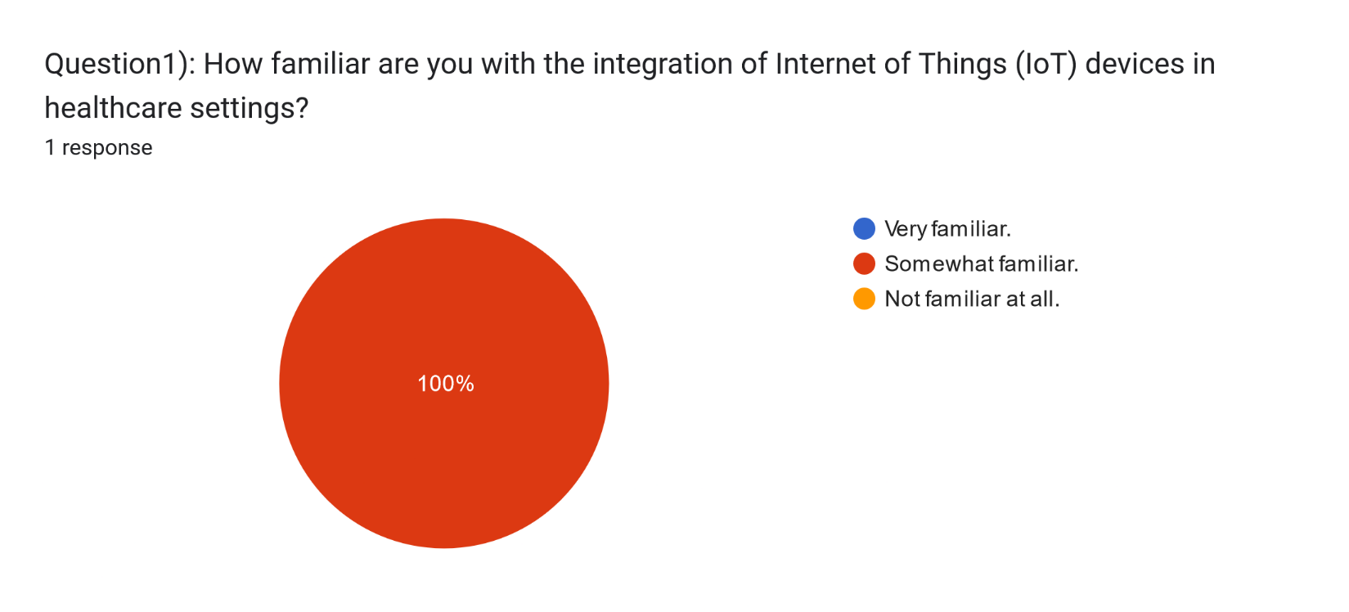

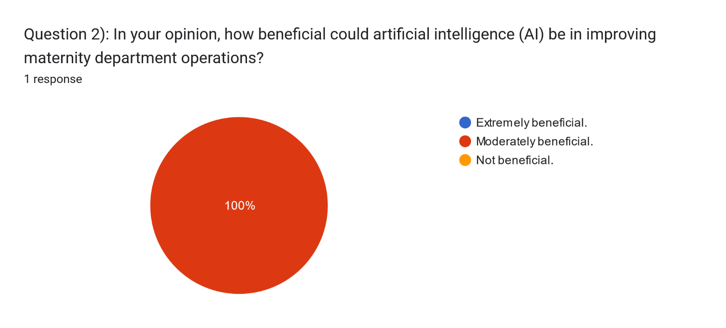

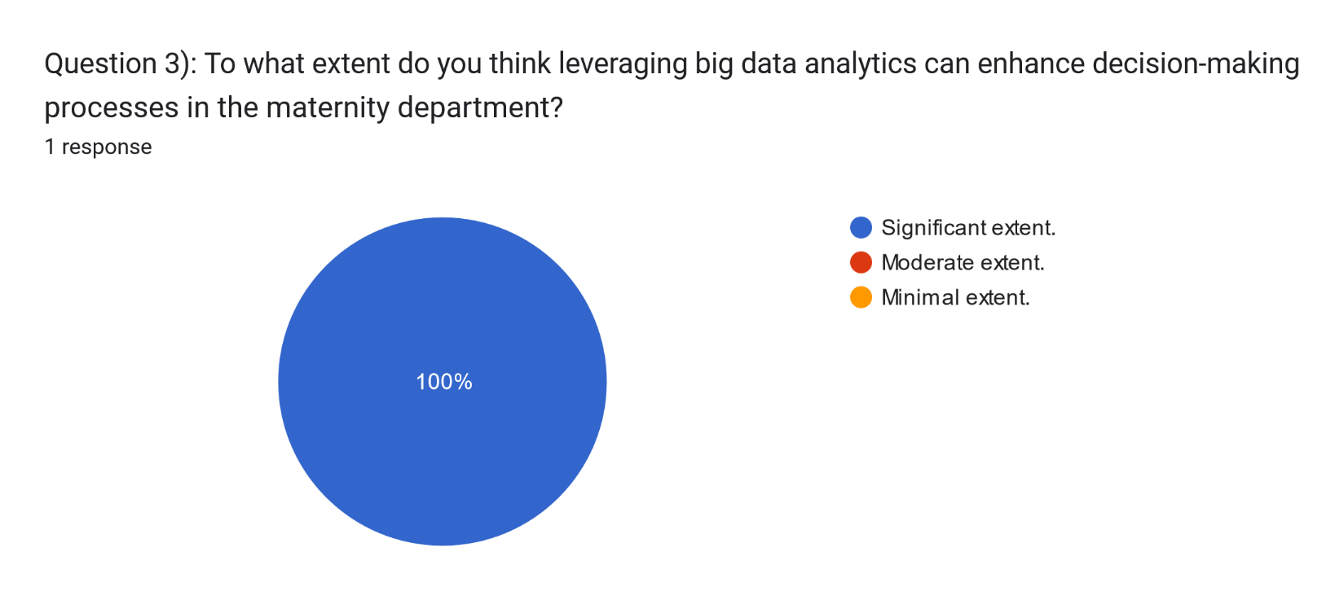

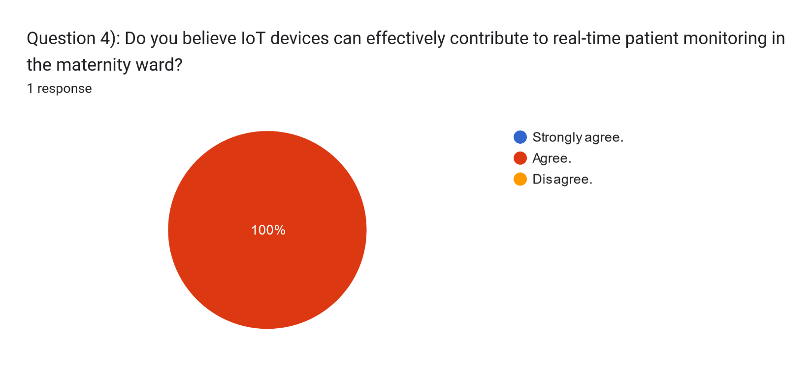

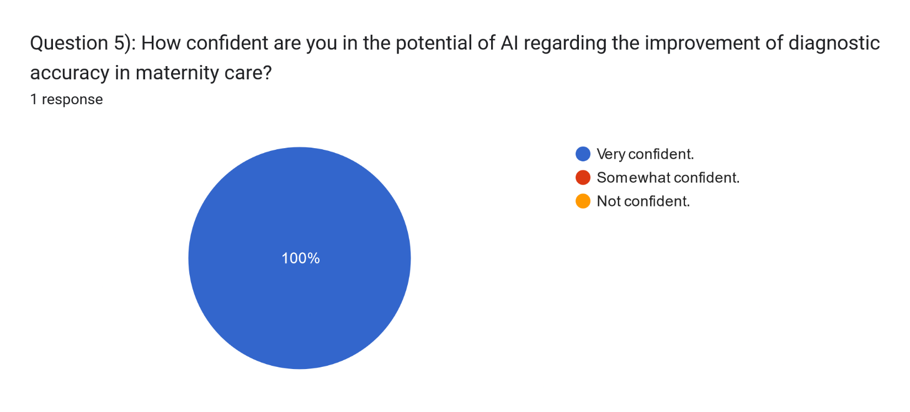

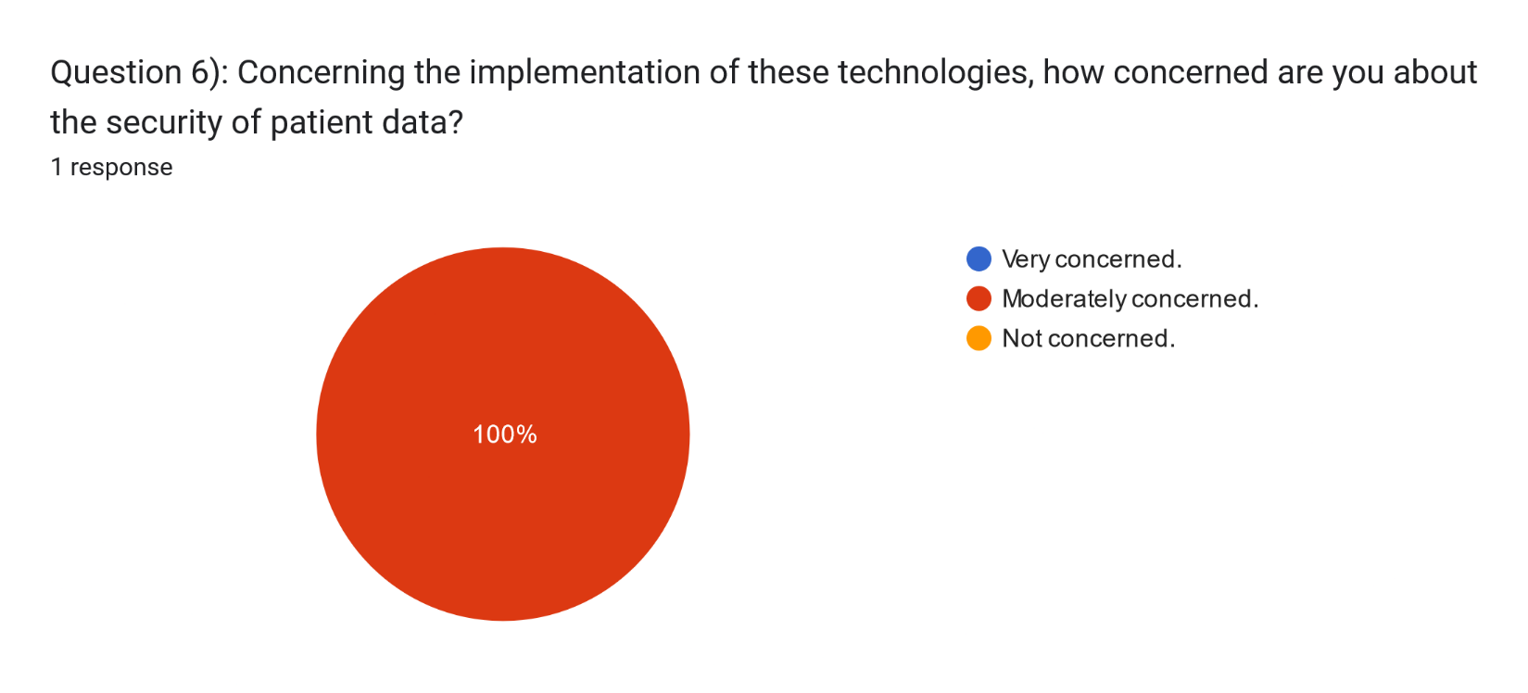



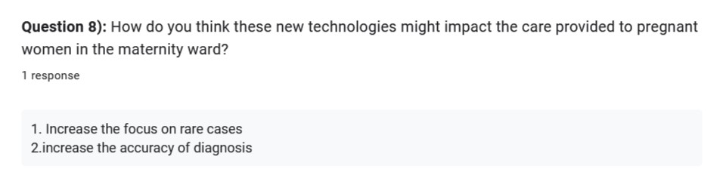

Maternity patient, the second interview aimed to gather additional data for Irbid Specialist Hospital's research. To protect the patient's privacy, their identity will be kept confidential at the patient's request. The questions asked during this interview were not directly related to big data, the Internet of Things, or artificial intelligence in order to provide information to the maternity patient in a clear and understandable manner. Instead, I focused on exploring the concept of smart hospitals in a clearer and more accessible way. A total of 8 questions were presented to the patient, including 6 closed questions covering different aspects of the topic in a multiple-choice format and 2 open-ended questions. Below, I will present the results of the patient interview and the questions I asked carefully and thoughtfully:

Link to the questionnaire and interview questions: <https://forms.gle/FSsw2EuQkFDhtP5T6> .

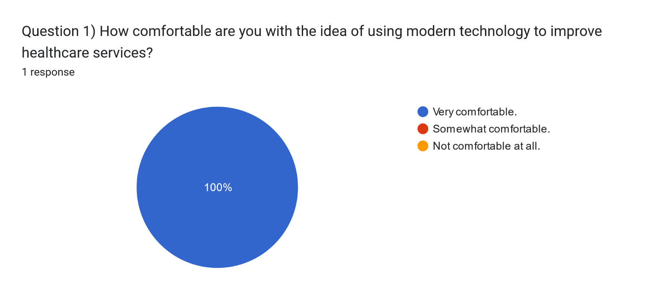

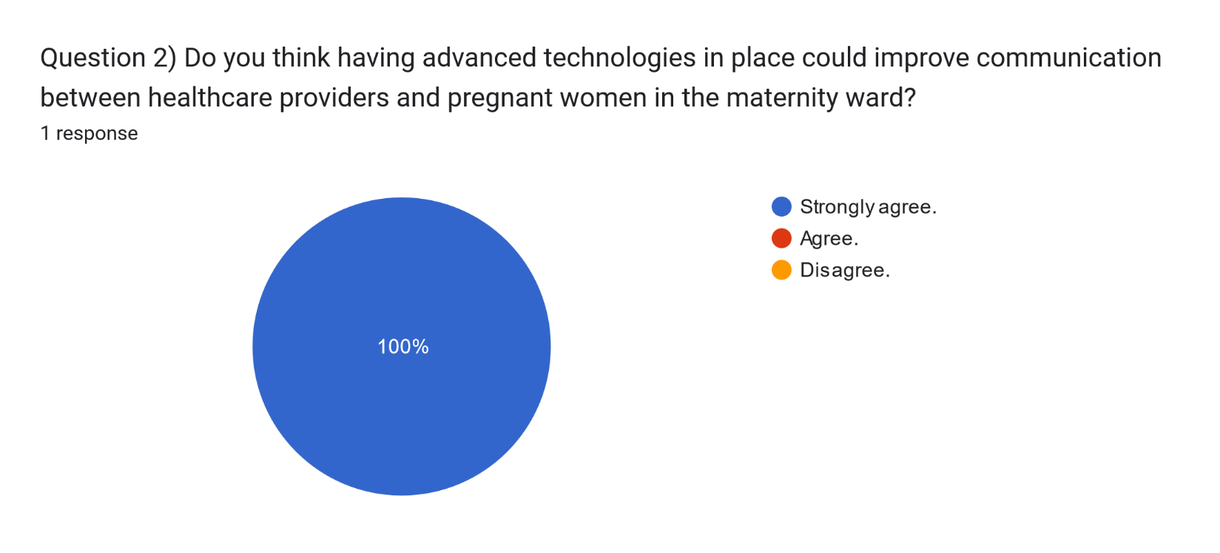

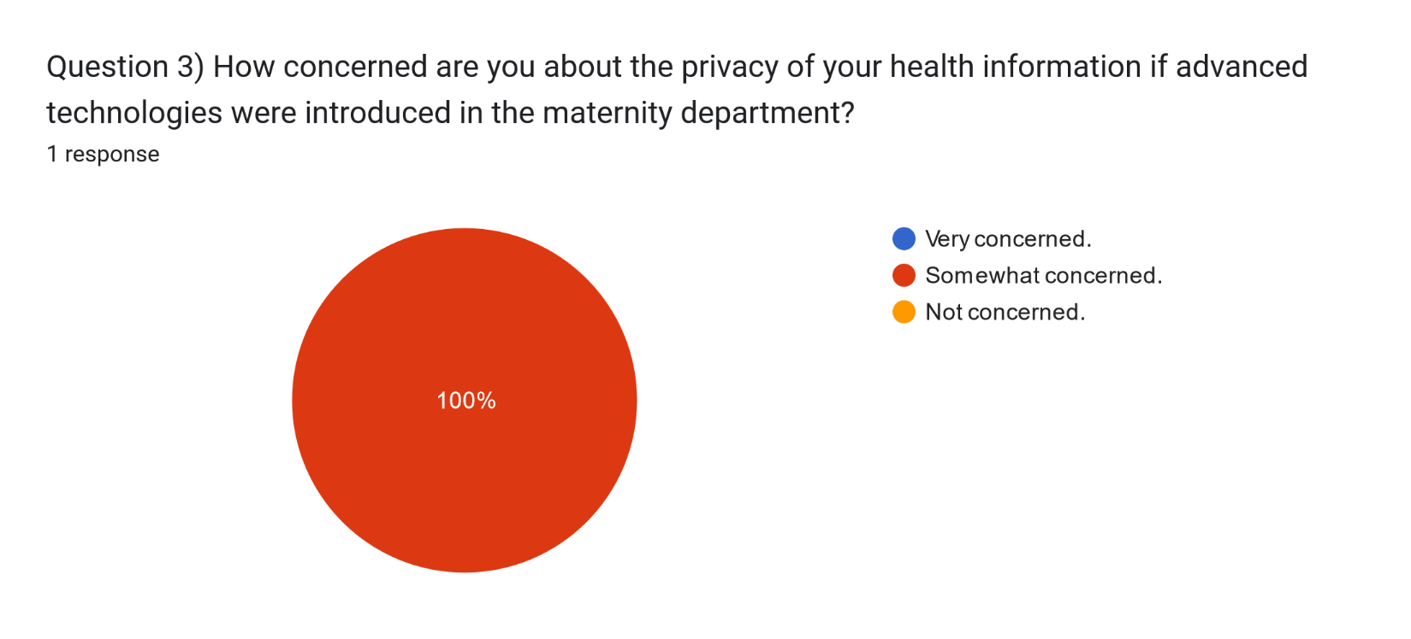

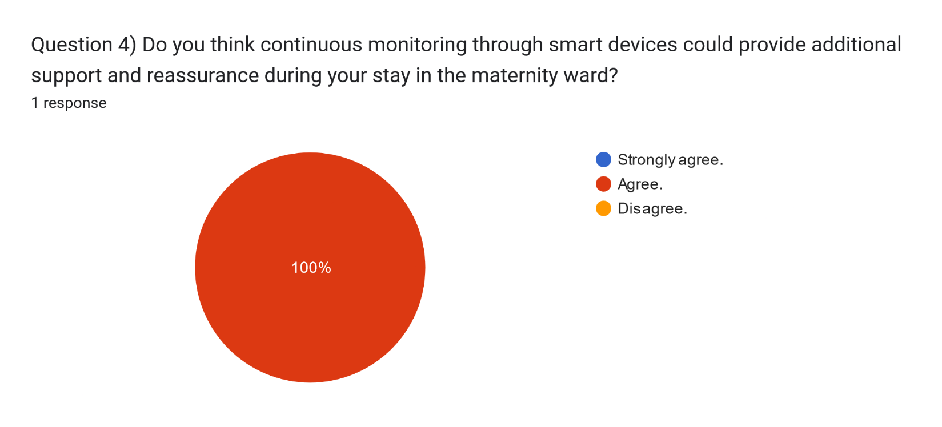

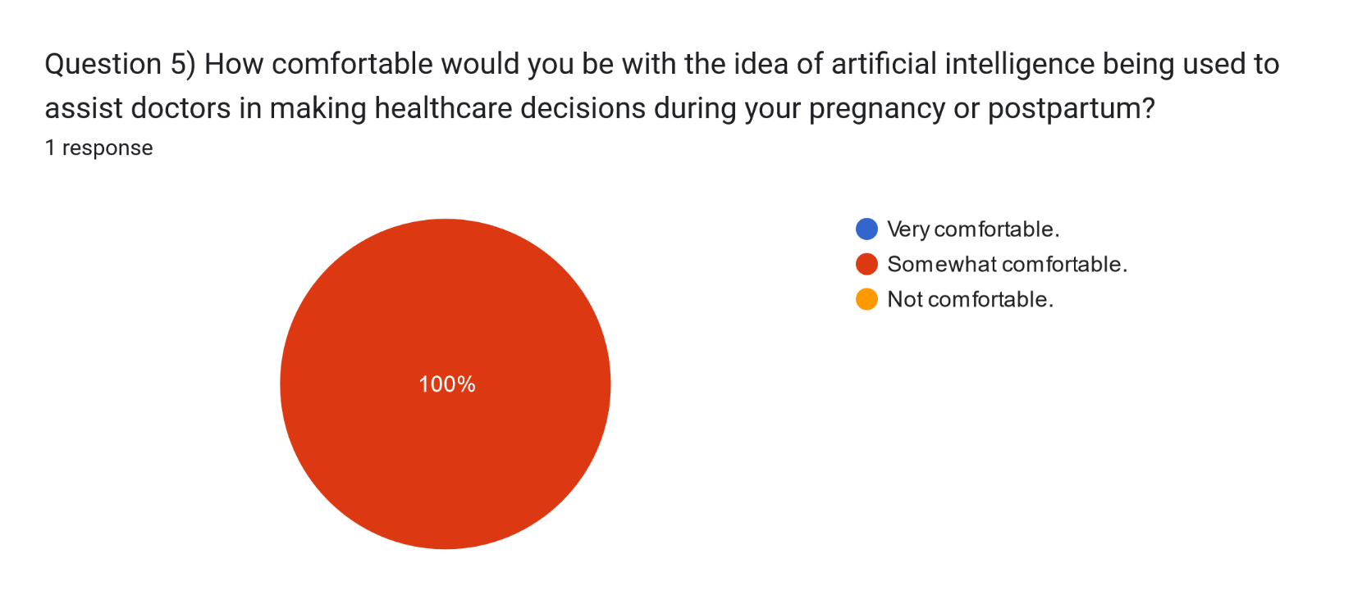

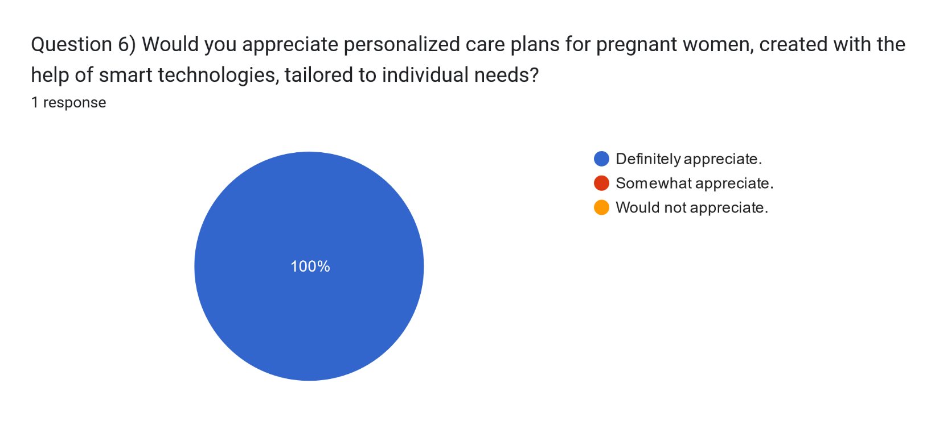

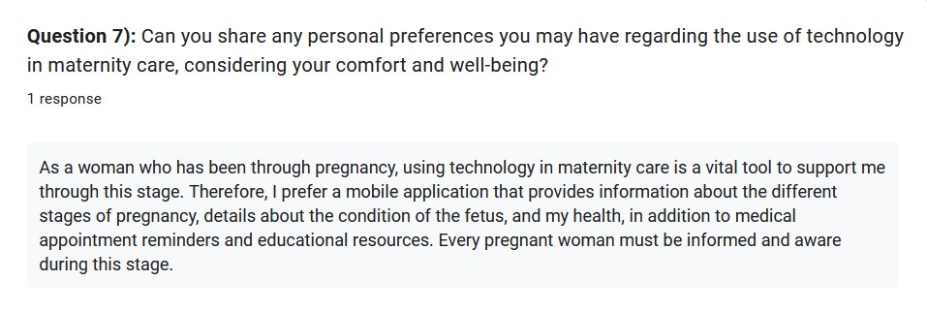

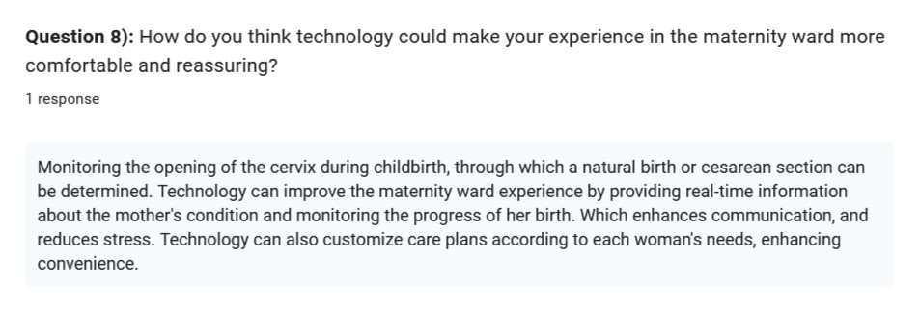

1. CONCLUSION

In conclusion, this research project sheds light on the challenges and opportunities associated with the integration of Big Data, the Internet of Things (IoT), and Artificial Intelligence (AI) technologies in the maternity ward at Irbid Specialist Hospital. The study recognizes the significance of a strategic approach to technology implementation, emphasizing the need for clear technology-driven strategies and centralized IT systems to mitigate challenges related to data duplication and system inefficiencies. The findings also underscore the importance of addressing security and privacy concerns, ensuring data accuracy, and promoting cost-effective solutions in the transformation towards smart hospitals.

Several recommendations can be made for both doctors and patients. For medical professionals, it is crucial to enhance familiarity with IoT devices in healthcare settings and address concerns related to security through training and awareness programs. Additionally, collaborative efforts should be made to establish a clear strategy for technology integration, promoting centralized data systems to improve efficiency. For patients, promoting awareness about the benefits of technology in healthcare and addressing concerns related to privacy through transparent communication are essential.

The insights from interviews with both medical professionals and maternity patients highlight varying perspectives on the benefits and concerns associated with these technologies, emphasizing the need for a balanced approach that prioritizes patient comfort, privacy, and personalized care.

.

References

1. Chinyere. N., U. and H. U., E.V. (2023). Qualitative Research. (2579-0803), pp.20–34.
2. Ettiyan, R. and Geetha, V. (2023). Iod-Nets – An IoT based intelligent health care monitoring system for ambulatory pregnant mothers and fetuses. Measurement: Sensors, [online] 27, p.100781. doi: https://doi.org/10.1016/j.measen.2023.100781.
3. H. Ali, Z., M. Badawy, M. and Arafat Ali, H. (2015). International Journal of Computer Applications. *Internet of Things (IoT): Definitions, Challenges and Recent Research Directions*, 128(1), pp.37–47.
4. Jing, S., Xiao, R., Shan, T., Wang, Z. and Liu, Y. (2020). *Application Practice of Smart Hospital Based on IoT Cloud Platform*, pp.1–2.
5. M. Krishnan, S. (2016). Application of Analytics to Big Data in Healthcare. IEEE, pp.156–157.
6. MP, S. (2019). Smart Hospitals: Challenges and Opportunities. pp.2–11.
7. Noonpakdee, W., Phothichai, A. and Khunkornsiri, T. (2019). *Challenges of Big Data Implementation in a Public Hospital*, pp.1–5.
8. R Hyman, M. and J. Sierra, J. (2016). Open- versus close-ended survey questions. 14(2), pp.1–5.
9. Rana, J., Oldroyd, J. and Luna Gutierrez, P.L. (2021). Quantitative Methods. pp.1–6.
10. SAGIROGLU, S. and SINANC, D. (2013). Big Data: A Review. pp.42–47.
11. Tecuci, G. (2012). Wiley Interdisciplinary Reviews: Computational Statistics. *Artificial Intelligence*, 4(2), pp.1–20.